ISO 21090 Healthcare Data types

Table of Contents

1 Purpose 3
2 ISO 21090 Healthcare Data types 3
3 NCI CBIIT ISO 21090 Localization 3
3.1 Platform Independent Model (PIM) 4
3.2 NCI CBIIT ISO 21090 Localization Common Library 5
3.2.1 Capabilities: 5
3.3 Future capabilities: 6
4 SDK & NCI CBIIT ISO 21090 Localization: 6
4.1 Capabilities: 7
4.2 Future capabilities: 7
5 References 9
6 APPENDIX A: Localized data types 9
7 APPENIDX B: Unmapped data types 11

Purpose
The purpose of this document to discuss current and future capabilities of NCI CBIIT ISO 21090 Localization Common Library and caCORE SDK.

ISO 21090 Healthcare Data types
The ISO 21090 Healthcare data types standard “provides a set of data type definitions for representing and exchanging basic concepts that are commonly encountered in healthcare environments in support of information exchange in the healthcare environment, [and] specifies a collection of healthcare related data types suitable for use in a number of health related information environments.”
An information processing product, system, element or other entity may conform to this International Standard either directly, by using data types specified in this International Standard in a conforming manner, or indirectly, by mappings from internal data types used by the entity to the data types specified in this International Standard.
The published specification of ISO/FDIS 21090:2009(E) standard can be referred at:
https://wiki.nci.nih.gov/display/ISO21090/ISO+21090+Published+Standard

NCI CBIIT ISO 21090 Localization
The NCI CBIIT Enterprise Conformance and Compliance Framework (ECCF) document requires that, in order to achieve Computable Semantic Interoperability (CSI), each attribute of a static information model should be bound to a robust data type specification.
NCI CBIIT ISO 21090 Localization is Specialized/constrained version of the ISO 21090 Healthcare Data Types. Localization is the list of approved ISO 21090 data types that will be maintained by CBIIT, along with common implementation artifacts. Localization provides indirect conformance to ISO 21090 Healthcare data types by:
- Providing mappings between internal data types and the healthcare data types
- Specifying for which of the data types an inward mapping is provided, for which an outward mapping is provided, and for which no mapping is provided
- Specifying whether the XML representation described herein is used when the data types are represented in XML, or optionally to provide an alternative namespace for the XML representation

Platform Independent Model (PIM)
The ECCF's Conformance certification framework provides for three levels of specification of a component from its conception to its implementation, requiring cohesive traceability between the three levels, and with the level of abstraction decreasing and levels of detail increasing as one goes from conception to implementation.
The Platform-independent Model (PIM) specification addresses the business functionality and behavior of data types, independent of the technology that implements it. The PIM specification, also known as the logical model specification, refines and constrains the functional and behavioral information.
The ISO 21090 Healthcare data types PIM document details the inward and outward mappings for each data type included in the localization.
https://ncisvn.nci.nih.gov/WebSVN/filedetails.php?repname=ISO21090&path=%2Fbranches%2Fv2_1%2Fdocuments%2FPIM_21090.pdf
Data types not included in this document have no mapping and are not part of the localization. Inward and outward transformations of localized data types to ISO 21090 data types is not part of this document. This document focuses on how a localized data type is mapped to ISO 21090 data type inward and outward.
All mapped ISO 21090 data types are listed in APPENDIX A below.
All unmapped ISO 21090 data types are listed in APPENDIX B below.

NCI CBIIT ISO 21090 Localization Common Library
“NCI CBIIT ISO 21090 Localization Common Library” is a Java implementation of the PIM mentioned above. The overall architectural methodology of this library is as shown below:
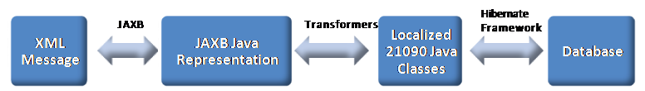
An XML message conforms to the ISO 21090 XSD as published by ISO is serialized into JAXB Java representation and transformed to a mapped localized java representation. The Hibernate framework provided by the library can be used to generate mappings between localized java representation of domain objects to a database model. Similar logic is followed to represent a localized data object as an XML message conforms to the ISO 21090 XSD.
Fully tested and implemented release of “NCI CBIIT ISO 21090 Localization Common Library” can be downloaded at http://gforge.nci.nih.gov/frs/?group_id=669.

Capabilities:
The “NCI CBIIT ISO 21090 Localization Common Library” capabilities are categorized and explained below:
Localized data types: This package represents all localized ISO 21090 data types authorized by NCI CBIIT.
Extension Framework: This package represents transformers to perform inward and outward mappings between localized and full java representation of ISO 21090 data types. This package also includes marshalling and unmarshalling APIs to support transformation between XML and JAXB Java representation and vice versa.
Hibernate Framework: This package represents Hibernate extensions to support localized ISO 21090 data types mappings to a database representation. Following are the extensions available:
- Hibernate Components: "Component" element represents the object whose properties are mapped to the columns in the table of the parent class. Component can be an attribute within the parent class, or identity attribute, or collection element.
- Composite Elements and Nested Composite Elements: The composite-element is a data structure that maps to a table other than the table of the parent class. The composite-element follows the structure similar to the component and behaves very much like the component. This mapping element would allow us to represent the collection types. The nested-composite-element in the Hibernate is an inner element inside the composite-element. This element would allow us to gain fine grained control over the elements of the collection types.
- Tuplizers: Provides control over the initialization process of the data type to specify constants and NullFlavor.
- Property Accessors: Provides control over a property of the class or attribute is being constructed and set in the Hibernate mapped objects.
- User Types: Hibernate provides built-in support for most common database data types and their translation into corresponding Java types. In order to support the ISO 21090 data types, we need a mechanism to convert few additional Java types (e.g. Code, Uri, Url, Enum etc) from their String representation into corresponding target type.

Future capabilities:
Full localization: Latest version of NCI CBIIT ISO 21090 Localization Library (v2.2) supports limited set of data types from the specification. Please see APPENDIX A for the list data types supported. Future capabilities of this library are to update PIM document for all data types with inward and outward mappings and provide full implementation.

SDK & NCI CBIIT ISO 21090 Localization:
The caCORE SDK is a set of development resources that allows you to create, compile, and run caCORE-like software. The SDK is designed to aid programmers with life science backgrounds who are interested in using or extending the capabilities of caCORE.
The primary benefits of using caCORE SDK include:
- Consistent UML representation of the data - Users of the caCORE SDK are required to represent their data management framework in UML format. The same UML model is used further downstream by tools for semantic integration and registering metadata.
- Rapid data service generation- The SDK can generate caBIG silver-level compatible system quickly from the UML model. Once the UML model and the database are ready, the data service can be generated in a matter of hours. Manually building the application from the ground up can take several months to achieve the same functionality.
- Uniform way to access data - SDK-generated systems provide uniform access to the data stores through standard client APIs that use the UML domain model. Thus a single client application can be written to access multiple SDK generated systems easily.
- Query using information model - SDK-generated systems use Query by Example format which allow for easy programmatic access of systems using standard client APIs and traversal of the UML model.
- Integration with caGrid - SDK generated systems can be easily integrated with the caGrid using the Introduce Toolkit without requiring any additional code.
The overall process of creating a grid enabled data service using ISO 21090 data types is as follows:
- Use Enterprise Architect or ArgoUML to develop Object and Data Models.
- Use caAdapter MMS to easily map elements between the Object using ISO 21090 data types and Data Models. caAdapter follows ISO 21090 mapping specification guidelines to generate required UML format for SDK.
- Use caCORE SDK to create the persistence layer (including Object/Relational mapping) and generate the Java and REST APIs.
- Use Introduce Data Service extension to create a caGrid Data Service.



Capabilities:
Apart from the standard capabilities, SDK integrates with NCI CBIIT ISO Localization Library providing following capabilities to generate ISO 21090 data types enabled system generation:
  - The caCORE SDK uses the UML model components in order to generate the entire caCORE like system. The SDK reads 1) Logical Model, 2) Data Model, 3) UML Tag values (GME, documentation etc), and 4) Model Mapping information (tag values). As ISO 21090 complex data types are used, SDK enhanced its UML model specifications to aid users to create the UML models based on ISO 21090 data types.
  - SDK uses NCI CBIIT ISO 21090 Localization Library Hibernate framework and generate database mappings based on logical and data model presented in a given UML model.
  - Provides ISO 21090 data type support within the SDK generated web application user-interface. SDK generated web application UI support specifying search criteria, validate, execute and display results that contain ISO 21090 data type attribute values that are complex and / or composite in nature, containing various values for a single attribute.
  - Incorporates JAXB technology for the marshaling and unmarshaling of both ISO 21090 data types, and non-ISO data types.
  - Generates eXtensible Markup Language (XML) based representation of the data types suitable for use when exchanging information between information processing entities.
  - RESTful and JSON interface to query domain data of ISO 21090 data types. The basic syntax of the RESTful query URL remains the same as in the previous release except that ISO 21090 data types adds support for simple data types, complex data types, complex data types with simple and complex attributes, complex data types with collection attributes, collection of complex data types, and, finally, complex collection of complex data types with collection attributes.

Future capabilities:
ISO 21090 Transformation Service:
Current release of SDK is tightly integrated with NCI CBIIT ISO 21090 Localization Library to support caCORE SDK like system that can work on data sets. This would require users to adapt ISO enabled release of SDK and generate their system again to be in compliance with the localization. It would also mean that any existing SDK generated services would not be able interoperate with ISO 21090 enabled services generated by SDK.
Proposed transformation service would follow SOA principles and be implemented as a Service Agent to provide transformation capabilities at runtime between ISO 21090 data constructs and non-ISO 21090 enabled services.
Transformation service will be deployed as a Service Agent where it can inspect incoming requests and look at defined policies and rules for ISO 21090 data types conversion and convert the request to suit a ISO 21090 enabled data service. Similar process is followed when a ISO 21090 enabled service is responding to a non-ISO 21090 client request. Following conceptual diagram represents the capability.

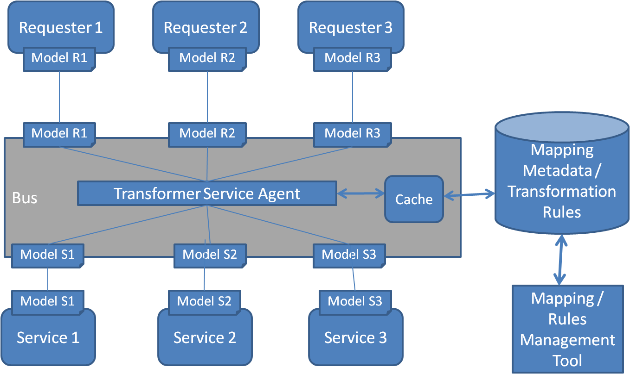

ISO 21090 enabled client-side UI widgets: The complexity of ISO 21090 data types requires considerable work to represent associated data in a user-friendly or customized way. SDK code generation could generate client-side UI widgets representing each of the ISO data types those can be easily included or customized into a web interface.
ISO 21090 enabled web application UI: SDK could generate fully automated customizable web application UI using client-side widgets for a system.
Support full ISO 21090 localization: Because of complexity of ISO 21090 data type structures, SDK will need to add more code generation capabilities specific to additional ISO 21090 data types get introduced in full implementation of NCI CBIIT ISO 21090 localization library.
ISO 21090 enabled writable API: Current version of SDK does not support writing data into persistent storage for ISO 21090 enabled domain objects. Future capability is to include this feature.
ISO21090 enabled instance and attribute level security: Current version of SDK does not support securing ISO 21090 enabled domain objects. Future capability is to include this feature.
ISO21090 enabled Webservice API: Current version of SDK does not support generating ISO 21090 enabled Webservice API. Future capability is to include this feature.
Validations: Current SDK does not support permissible values validation, hibernate validation for an ISO 21090 enabled system generation. Future capability is to include this feature.

References
https://wiki.nci.nih.gov/display/ISO21090/
https://wiki.nci.nih.gov/display/ISO21090/NCI+CBIIT+ISO+21090+Support+in+caCORE+SDK%2C+caAdapter%2C+and+caGrid
https://ncisvn.nci.nih.gov/WebSVN/filedetails.php?repname=ISO21090&path=%2Fbranches%2Fv2_1%2Fdocuments%2FPIM_21090.pdf

APPENDIX A: Localized data types
- Basic Data Types
  - Any
  - BL
  - BL.NONNULL
- Text and Binary Data Types
  - ED
  - ED.TEXT
  - ST
  - ST.NT
  - SC
- Coded Data Types
  - CD
- Identification and Location Data Types
  - TEL
  - TEL.URL
  - TEL.PERSON
  - TEL.PHONE
  - TEL.EMAIL
  - II
- Quantity Data Types
  - INT
  - QTY
  - PQ
  - PQV
  - REAL
  - TS
- Continuous Set Data Types
  - QSET
  - IVL<INT>
  - IVL<PQ>
  - IVL<REAL>
  - IVL<TS>
- Collection Data Types
  - COLL
  - DSET
- Name and Address Data Types
  - AD
  - ADXP
  - ADXP.ADL
  - ADXP.AL
  - ADXP.BNN
  - ADXP.BNR
  - ADXP.BNS
  - ADXP.CAR
  - ADXP.CEN
  - ADXP.CNT
  - ADXP.CPA
  - ADXP.CTY
  - ADXP.DAL
  - ADXP.DEL
  - ADXP.DINST
  - ADXP.DINSTA
  - ADXP.DINSTQ
  - ADXP.DIR
  - ADXP.DMOD
  - ADXP.DMODID
  - ADXP.INT
  - ADXP.POB
  - ADXP.PRE
  - ADXP.SAL
  - ADXP.STA
  - ADXP.STB
  - ADXP.STR
  - ADXP.STTYP
  - ADXP.UNID
  - ADXP.UNIT
  - ADXP.ZIP
  - EN
  - EN.ON
  - EN.PN
  - ENXP

APPENIDX B: Unmapped data types
The following data types are defined by ISO 21090 but are not part of this localization:
- HXIT
- ED.IMAGE
- ED.DOC
- ED.DOC.INLINE
- ED.DOC.REF
- ED.SIGNATURE
- ED.STRUCTUREDTEXT
- ED.STRUCTUREDTITLE
- CD.CV
- CS
- EN.TN
- INT.NONNEG
- INT.POS
- CO
- RTO
- PR
- PQR
- PQ.TIME
- MO
- TS.DATE
- TS.DATE.FULL
- TS.DATETIME
- TS.DATETIME.FULL
- TS.BIRTH
- LIST (Sequence)
- GLIST (Generated Sequence)
- SLIST (Sampled Sequence)
- HIST (History)
- BAG (Bag)
- QSU (QSET Union)
- QSI (QSET Intersection)
- QSD (QSET Difference)
- QSP (QSET Periodic Hull)
- QSS (QSET Set)
- IVL.CO
- IVL.RTO
- IVL.MO
- PIVL (PerioticInterval)
- EIVL (Event-Related Periodic Interval of Time)
- GTS.BOUNDEDPIVL
- UVP (Uncertain Value – Probabilistic)
- NPPD (Non-Parametric Probability Distribution)
- URG (Uncertain Range)
- URG.LOW
- URG.HIGH
- StructuredDoc

ISO/FDIS 21090:2009(E) – Page 1.

